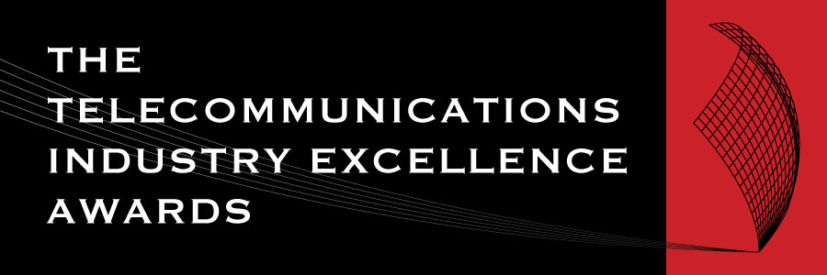 | 2025 AWARD  NOMINATION FORM

AWARD CATEGORY: INNOVATION IN MOBILE
For providing innovative mobile solutions,products, or technological advances
Open to: All organisations offering mobile networks, infrastructure, products, services and technology

IMPORTANT DATES
Launch of the Awards/Nominations open | Wednesday 2 April 2025
Nominations Close | Friday 2 May 2025
Announcement of Shortlist | Wednesday 4 June 2025
Awards Dinner and Awards Presentations | Thursday 24 July 2025

NOMINATION CHECKLIST
- The nominated offering must be commercially available and have been introduced to the marketplace within 2024/25 or earlier. | ▢
- The nominee’s company is registered and operating in Australia (ABN on request. | ▢
- The nominee owns the IP of the solution which they are nominating for the award. | ▢
- This mobile product or service did NOT win an ACOMM Award in 2024. | ▢
- Each section of the Nomination form has been completed. | ▢
The judges can only assess the nomination on the information and materials supplied on the nomination form, so we advise nominees to provide as much information as possible including the suggested inclusions and supporting testimonials.

AUTHORISATION
By submitting my nomination electronically, I hereby declare that the information provided for the 2025 Telecommunications Industry Excellence Awards entry is accurate and correct. I also agree to abide by the judging decisions made by the judging panel and their decisions will be accepted and final.
Name
Company

Name of the mobile product or service nominated for this award.
Date product or service introduced to the market.

CRITERIA (Maximum 500 words each)
1 | Describe the innovative mobile product or service.
2 | Explain how the mobile solution was introduced to the market
3 | What is the market uptake to date?

SUGGESTED INCLUSIONS:
- What customer need does your new mobile service/product fulfil?
- How does your offering differ from those of your competitors?

DO NOT FORGET TO INCLUDE SUPPORTING TESTIMONIALS.

NOMINATION OVERVIEW
Concise company profile overview.
(max. 250 words)
Short description of the entry.
(max. 50 words)
Please upload a high res (.eps, .ai, .svg, .pdf) version of your company logo to this Dropbox link.
We will only use your logo if your entry is shortlisted as a finalist in its given category.

