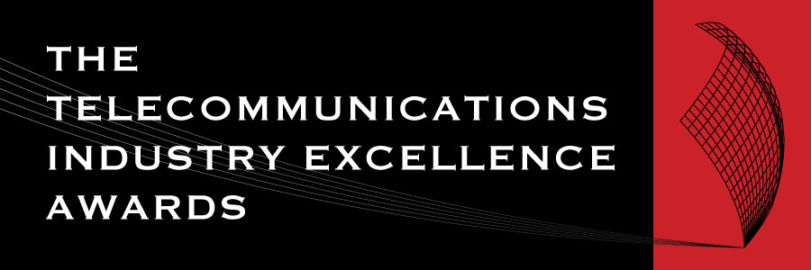 | 2025 AWARD  NOMINATION FORM

AWARD CATEGORY: CONSUMER CHAMPION AWARD
For an individual who has shown outstanding results in improving outcomes for consumers
Open to: All individuals

IMPORTANT DATES
Launch of the Awards/Nominations open | Wednesday 2 April 2025
Nominations Close | Friday 2 May 2025
Announcement of Shortlist | Wednesday 4 June 2025
Awards Dinner and Awards Presentations | Thursday 24 July 2025

NOMINATION CHECKLIST
- The individual’s contribution is current and is expected to be ongoing. | ▢
- Each section of the Nomination form has been completed. | ▢
The judges can only assess the nomination on the information and materials supplied on the nomination form, so we advise nominees to provide as much information as possible including the suggested inclusions and supporting testimonials.

AUTHORISATION
By submitting my nomination electronically, I hereby declare that the information provided for the 2025 Telecommunications Industry Excellence Awards entry is accurate and correct. I also agree to abide by the judging decisions made by the judging panel and their decisions will be accepted and final.
Name
Company

Name of the individual nominated for this award.

CRITERIA (Maximum 500 words each)
1 | Describe the individual’s  contribution to improving  outcomes for consumers.
2 | Describe specific consumer  benefits that have resulted from  this individual’s efforts.

SUGGESTED INCLUSIONS:
- Endorsements from people or organisations which have benefitted from the nominee’s work.
- How have consumers benefitted from this individual’s efforts?

DO NOT FORGET TO INCLUDE SUPPORTING TESTIMONIALS.

NOMINATION OVERVIEW
A brief biography for the individual.
(max. 250 words)
Short description of the entry.
(max. 50 words)
Please upload a high res headshot of the individual to this Dropbox link.
We will only use this image if your entry is shortlisted as a finalist in its given category.

